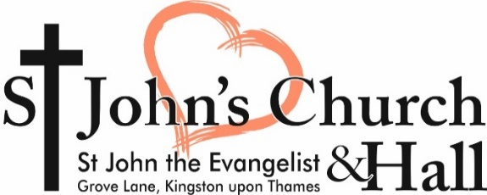

20th June 2021

THE COLLECT:

Almighty God,
you have broken the tyranny of sin
and have sent the Spirit of your Son into our hearts
whereby we call you Father:
give us grace to dedicate our freedom to your service,
that we and all creation may be brought
to the glorious liberty of the children of God;
through Jesus Christ your Son our Lord,
who is alive and reigns with you,
in the unity of the Holy Spirit,
one God, now and for ever.

THE READING: Job 38. 1-11
Then the Lord answered Job out of the whirlwind:
‘Who is this that darkens counsel by words without knowledge?
Gird up your loins like a man,
I will question you, and you shall declare to me.
‘Where were you when I laid the foundation of the earth?
Tell me, if you have understanding.
Who determined its measurements—surely you know!
Or who stretched the line upon it?
On what were its bases sunk,
or who laid its cornerstone
when the morning stars sang together
and all the heavenly beings shouted for joy?
‘Or who shut in the sea with doors
when it burst out from the womb?—
when I made the clouds its garment,
and thick darkness its swaddling band,
and prescribed bounds for it,
and set bars and doors,
and said, “Thus far shall you come, and no farther,
and here shall your proud waves be stopped”?

THE GOSPEL: Mark 4.35-41
Hear the Gospel of our Lord Jesus Christ according to Mark
All: Glory to you, O Lord
On that day, when evening had come, he said to them, ‘Let us go across to the other side.’ And leaving the crowd behind, they took him with them in the boat, just as he was. Other boats were with him. A great gale arose, and the waves beat into the boat, so that the boat was already being swamped. But he was in the stern, asleep on the cushion; and they woke him up and said to him, ‘Teacher, do you not care that we are perishing?’ He woke up and rebuked the wind, and said to the sea, ‘Peace! Be still!’ Then the wind ceased, and there was a dead calm. He said to them, ‘Why are you afraid? Have you still no faith?’ And they were filled with great awe and said to one another, ‘Who then is this, that even the wind and the sea obey him?’
This is the Gospel of the Lord
All: Praise to you O Christ

FOR YOUR PRAYERS
Please pray for those who are ill and those in particular need of prayer:
Beate, Reza, Mehrzad, Faezeh, Mick & Ann, Nicole, Chris, Omid, Rita, Shaida, Laura, Diana, AliMuliang, Dave, Riley, Helen, Peter, Anita, Emma, Huxley, Daphne and Julie.
RIP
Joseph Childs whose years mind occurs at this time

NEWS & NOTICES

JOINING FLOWER ROTA
We are always looking for people to help arrange the flowers in Church. If you would like to take a turn on the flower rota, please speak to Mark
.
LITTLE GROOVERS
We are pleased to announce that our Stay and play sessions for the under 5s has returned on Thursday mornings from 9.30 until 12.00 during Term Time. Sessions will be £3.50 per family and includes refreshments. Due to Government restrictions pre-booking is essential for more information please contact littlegroovers.stjohnskingston@gmail.com

ST JOHNS PRIMARY SCHOOL
This year our church school is 150 years old. The school is planning a week of celebratory events, part of these events will include an exhibition of photos & memorabilia of the school Now & Then. The school are looking for items for the exhibition such as photos, old books, uniform etc . or do you have any stories of your time at the school you would like to share? If you have anything that you wouldn’t mind lending the school please contact ahutch3@stjohns.rbksch.org

STUDENT ACCOMODATION
Does anyone have a room they would be prepared to rent room to a University student this September. The daughter of a colleague from Sacred Space church who lives in Cornwall is starting a course at Kingston University and is looking for lodgings with a Christian Family. For more information please contact Mark.

CHURCH PCC MEETING
Parish of St John the Evangelist
Kingston upon Thames
A meeting of the Parochial Church Council will take place on 22nd June 2021 at 8pm on Zoom.

Agenda to be circulated to PCC Members prior to the meeting. If any member of the congregation wishes to suggest any issues to be raised as Any Other Business at the Meeting please contact any PCC Member, the PCC Secretary, discuss with Mark or email:
pcc.stjohnskingston@gmail.com
CHURCH SERVICES

Tuesday to Saturday 9am
Morning Prayer. (Online Only)

Wednesday 6pm -7.30pm
Church Open for private prayer.

Sunday 9.15am
Diddy Disciples (0-6 year old’s) in church.

Sunay 10.30am
Parish Communion in Church and Online

Sunday 11.30am – 13.00pm
Church Open for Private Prayer

Sunday 7pm
Evening prayer (Online Only)

ALL SAINTS TOPICAL LUNCHES
Thursday 15th July @1pm
Staying Safe
PC Sean Jaundo, Policing Prevent Team

All meetings 1:00 – 1:45 pm. Short introduction, then questions, comments, discussion. Finish 1:45 pm sharp.
For information contact: info@allsaintskingston.co.uk

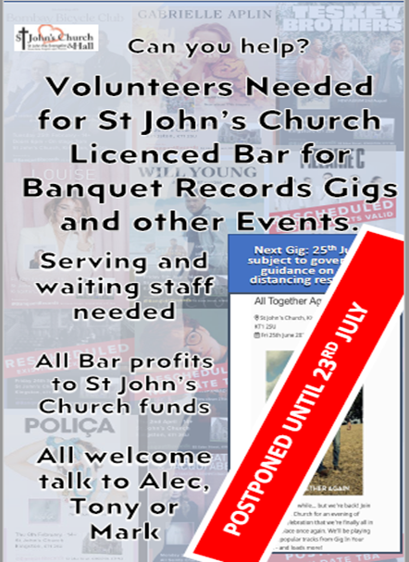
GIVING TO ST JOHN’S

Thank you! We rely on your regular giving to keep St John’s going and to support parishes with less resources via our monthly contribution to the Diocese. We are especially grateful to all who make monthly standing order gifts. As you know, we can’t take a formal collection during services at present so you’ll find the collection plate on the welcome table instead. If you don’t give by standing order please help by leaving a donation on the plate. There are Gift Aid envelopes here too.
For new standing orders or one-off gifts our account is:
Kingston St Johns DCC
Sort code: 60-60-02
Acc No: 11610220
Please mark your donation as ‘Gift’.

If you prefer a contactless option, we have a Card Reader available, or a simple way of giving is to point your camera on your phone to the QR code above and follow the link to givealittle.co.uk – you will need your debit card long number, expiry date and security code to complete the transaction. You will also find this link on our website – click on the DONATE button top right.

https://www.facebook.com/StJohnsKingstonUponThames
https://www.instagram.com/stjohnskingston/

